Exp no : 13 Keerthika.k
241901046
DEMONSTRATE NETWORK FORENSICS USING PCAPXRAY TOOLS

Aim:
To analyze captured network traffic using PcapXray and identify hosts, traffic patterns, and suspicious network activities for forensic investigation.
Algorithm:
- Install prerequisites:
- Install Python 3, pip, Graphviz, Tkinter, and required libraries.
- Clone the PcapXray repository and install dependencies using pip install -r requirements.txt.
- Prepare input:
- Obtain a .pcap file containing network traffic to be analyzed.
- Ensure the PCAP is from a safe/testing source for learning purposes.
- Launch PcapXray:
- Open main.py in the repository using Python.
- Load the selected .pcap file via the GUI.
- Analyze traffic:
- Observe the network graph of hosts (nodes) and connections (edges).
- Filter traffic based on Web, Tor, Malicious, DNS, or ICMP.
- Click on nodes/edges to view traffic details, HTTP requests, or extracted payloads.
- Record observations:
- Note suspicious hosts, unusual ports, or Tor traffic.
- Check extracted files or payloads for anomalies.
- Optionally, cross-verify suspicious IPs with WHOIS or threat intelligence sources.
- Document results:
- Capture screenshots of network diagrams and significant flows.
- Summarize the suspicious activities identified during analysis.

Output (status):
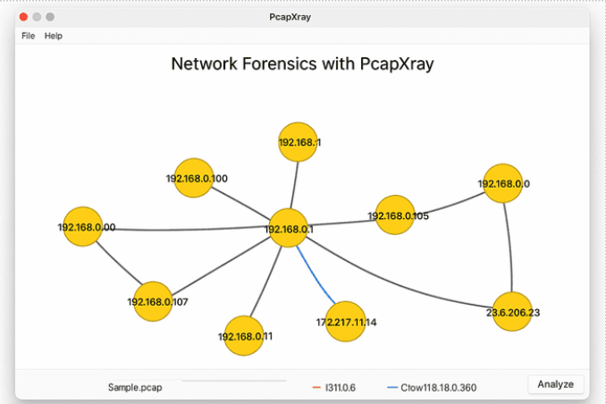

Result:
- Hosts with the most connections were identified as central nodes.
- Web traffic, Tor traffic, and DNS requests were visualized clearly.
- Suspicious or unusual traffic flows were highlighted for further investigation.
- Payload extraction revealed potential files or URLs of interest.

